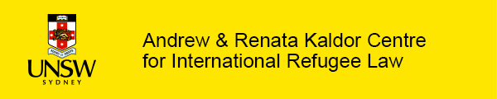

New training kit: Climate displacement and international protection

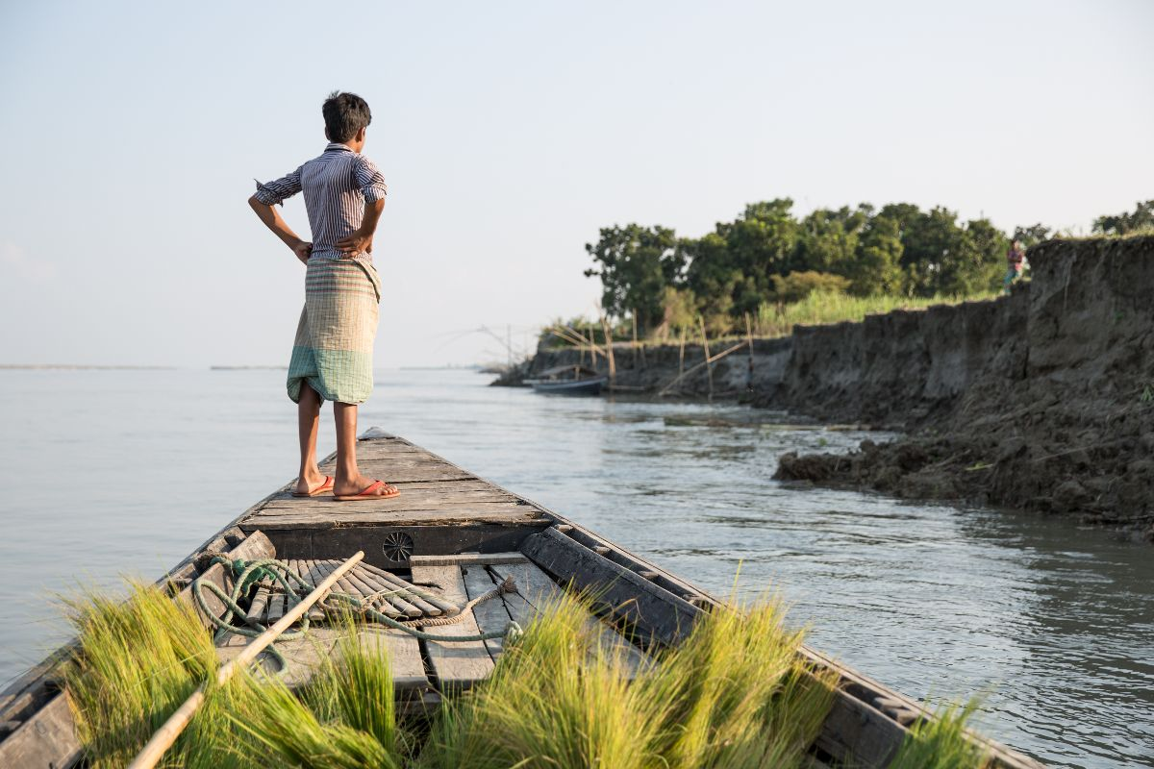

Climate displacement is no longer a future issue. Each year, millions of people are forced from their homes because of the impacts of climate change and disasters – and some cross international borders.
What does the law require in these cases?
Today the Kaldor Centre launches a free training kit for decision-makers and legal practitioners working on international protection claims involving climate change and disasters.
Developed by Professor Jane McAdam and Dr Tamara Wood, the self-guided materials build on the Practical Toolkit – a landmark resource the Kaldor Centre produced with leading global experts and UNHCR. It shows how refugee law and human rights law can provide protection in some situations where climate change and disasters play a role.
Legal clarity can make a life-saving difference.

Start the training now

Resources include:
- A step-by-step 12-minute training video
- Four hypothetical scenarios
- Participant worksheets
- Suggested activities for deeper learning
- Trainer notes and session structures for a tailored delivery

These resources offer clear, practical guidance grounded in real-world decision-making, helping practitioners navigate a rapidly evolving area of law. Decision-makers are already recognising the training kit’s value. Sharelle Aitchison, New Zealand Immigration and Protection Tribunal, described it as:
‘An admirably well-structured and accessible resource … dispelling false assumptions about climate change and disasters in the context of international protection.’
We are also offering two ‘train the trainer’ sessions in June 2026.

Explore all the training resources

While the training kit is designed for specialist audiences, the short video below makes the issues accessible to anyone interested in climate-related displacement and protection.

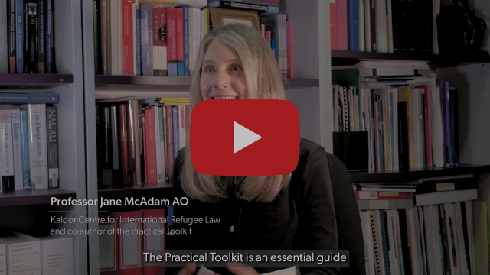
Watch a short introduction to see how the Practical Toolkit can help

The training forms part of the Climate Mobility Hub, reflecting the Kaldor Centre’s leadership in this field – bringing together rigorous research, legal analysis and practical tools developed with international partners and affected communities.
The Practical Toolkit is now available in Spanish, with a French version coming soon.

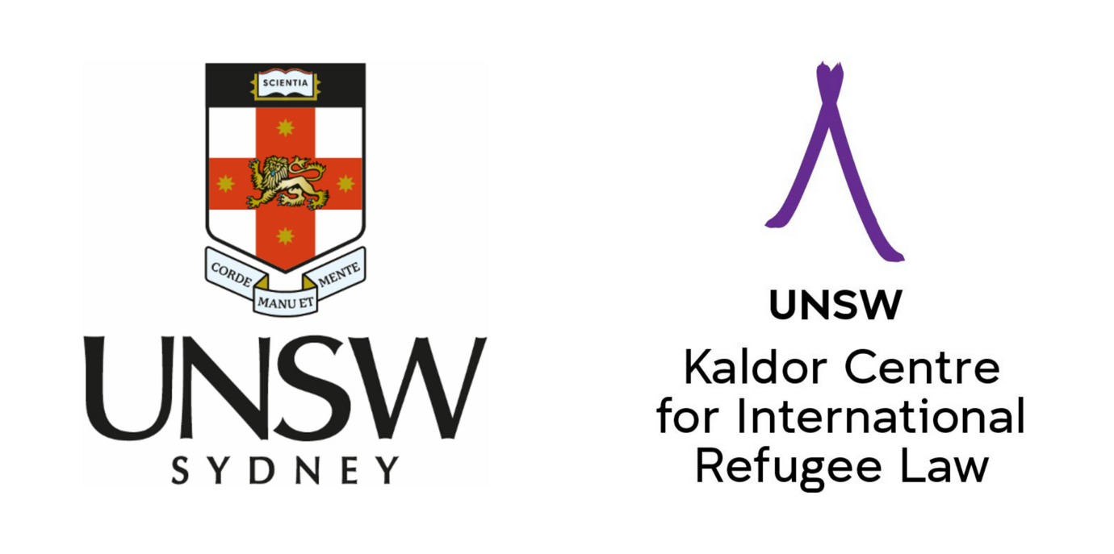

Andrew & Renata Kaldor Centre for International Refugee Law
Faculty of Law & Justice, UNSW Sydney, NSW 2052 Australia
www.kaldorcentre.unsw.edu.au
UNSW CRICOS Provider Code 00098G, ABN 57 195 873 179

